Student’s Name
Professor’s Name
Course
Date
Creative Voice Project
Event
On 24 Feb 2021, various news outlets in the United States, including NBC, CNN, and Washington Post, highlighted the story of the golf superstar Tiger Woods. They highlighted that Tiger Woods was involved in a car accident outside Los Angeles, Calif. The impact of this event was that it contributed to injuries. Tiger Woods sustained multiple life-threatening injuries. Tiger Woods was extricated by paramedics and firefighters and then taken into surgery at Harbor-UCLA Medical Center in Los Angela County. According to the LA sheriff, Tiger Woods was speeding at around 87mph before being involved in the car crash. It means that he was over-speeding. Investigations reveal that the accident occurred as a result of Wood's going beyond the legal speed limit. The Following are some of the images of this event (NBC News).
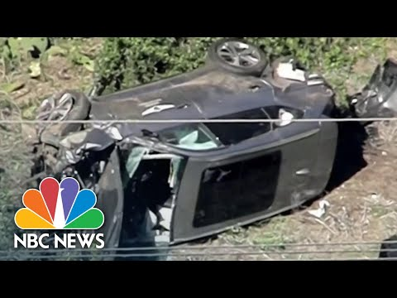
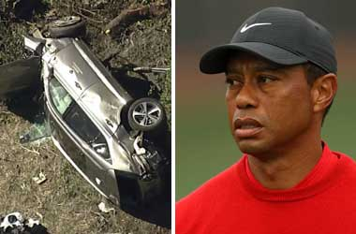
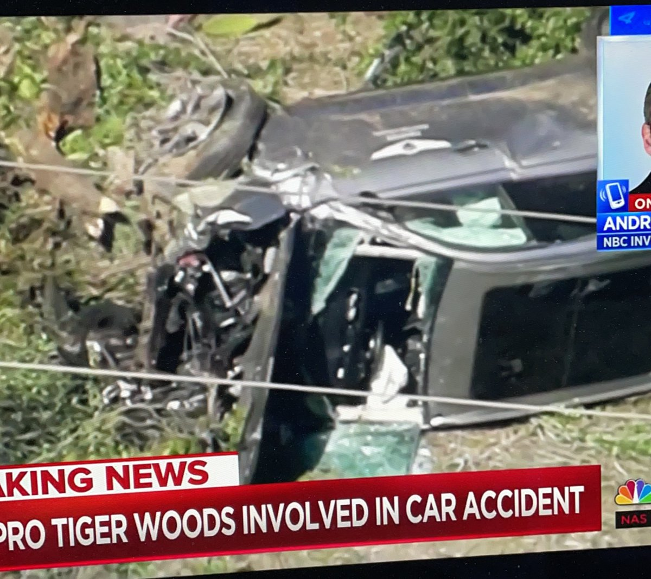

Impact of the Event
This event changed me because I used to be a poor or bad driver. Before watching this news, I used to over-speed due to varied reasons. For instance, I could over-speed when late for work to avoid being penalized by my employer. This news made me question my driving habit. I never wished to be in the same situation as Tiger Woods. I'm glad to report that I'm now a reformed driver who observes the stipulated speed limit. Apart from driving beyond the legal speed limit, I have also learned that people should not drive under the influence since this habit contributes to tragic road accidents.
Inspiration
I'm inspired by the poet Chelsea Lindsey. In her poem, The Car Accident, Lindsey talks about a car accident in the neighborhood. In this poem, the narrator talks about her experience with the road accident. It is clear that the narrator and the entire family died in this incidence. This artist inspired me because I will integrate several aspects of his work into my original work. One of these aspects is the theme. The theme is usually described as the central idea that the artist intends to share. Based on this artist, it is apparent that she develops the theme of accident and death. For instance, stanza nine and ten clearly depict how the narrator's parents and siblings died after the accident. Below is the proof of how the poet developed this theme:
My mother, who cared more than anyone else
Now lies lifeless and still
I wish so hard I could bring her back
By sheer power of will

My dad and siblings all have moved on
To a life much better than this
Yet I selfishly with they had stayed
So I would have no one to miss
Based on this inspiration, I will also ensure that my work communicates the theme of accident and death to the respective audience (Lindsey stanza 9-10).

My Original Work (Play)
Title: A Deviant Teenager
David: (He coughs before addressing his wife) I have keenly observed John and noted that he has changed for the worse.
Janet: (She seems surprised) What do you mean? I thought the advice we gave him some months ago transformed him?
David: (He wheels on his chair to face Janet) Janet. The boy has become very rude. To make matters worse, he has started drinking. A close friend of mine spotted him in the Roadside Bar in the company of three other young men. (He sighs).
Janet: What should we do now? He is our firstborn, and he needs to be morally upright for the sake of the family. I think it will be wise if we talk to him.
David: (Nodding his head in agreement). Helen…Helen!
Helen: (She responds while coming towards the sitting room) Yes, father.
David: Call John.
Helen: Okay, father.
(Helen walks out of the room. She surfaces back together with John. John stands hands akimbo looking at the parents without uttering a word)
David: Take a seat.
(Both Helen and John get seated staring in the direction of their parents).
David: We have asked Helen to call you for a reason. It is of significant concern that you have embraced destructive behaviors that might ruin your future.
John: (He interrupts the conversation). Which behaviors father?
Helen: John, why don't you be calm and listen?
David: (Addressing Janet) You can now, see! I have warned you severally to avoid that lousy company comprising Hitman and Steeler, but you have decided to do things your way. To worsen the situation, you have started drinking alcohol.
John: (He springs from the seat and talks while standing) You should understand that I am an adult, and I have the right to do what pleases me. It is the highest time you should stop monitoring me. Monitor Helen. (He pronounces the last words as he walks out of the door to ignite the family car).
Helen: (She stands to pursue John) John! John! Come back. Don't disrespect your father.
John: That is no disrespect. That is reality! (He yells as he speeds out of the compound)
Janet: That isn't nice of him.
David: What has befallen our son?
Helen: I think it is just bad company. I spotted him drinking alcohol in his room the other day.
(They look at each other surprised)
Janet: (In a scornful voice) And why did you fail to notify us?
Helen: I feared that he might develop hatred towards me. (Helen walks away to evade the heated debate).
(David's phone rings)
David: Hello! I can hear you.
Police: I am Jessy, a traffic police patrol officer. Your car has been impounded due to reckless driving. The driver who claims to be your son was overspeeding and also overtaking dangerously.
David: Can I talk to him, please?
Police: Okay (He hands over the phone to John)
David: Hello John. What is the matter?
John: Dad, they have flagged me for overspeeding. They have fined me $ 100.
David: Give the officer the phone
(John gives Jessy the phone)
Police: He should pay $100 as a fine.
David: Okay. Sorry for that. Let me transact. (David pays via mobile banking, and the police release John)
(John arrives startled and heads into his room to sleep without talking to anyone. The parents let him alone, wishing to speak to him the next day)
David: This young man will cost us water and firewood
Janet: True. We need to talk to him as much as we can. (John, who was listening from outside, jumps into the car and heads to town again)
David: I can hear the sound of the vehicle. He is leaving. (They stand and walk towards the veranda and witness John disappear)
Helen: (Disappointed). He will just come back.
(Everyone engages in other activities. After two hours, David's phone rings—John had caused an accident in town)
David: Hello.
Police: This is Central Police Station. Your car number 298 Volks has been involved in a road accident. The driver has been ferried to Pine Hospital.
David: (Surprised) Hello, officer. What happened? Is..Is.. he okay?
Police: The driver was drunk when he hit the rear of another car. He is in stable condition. He can talk.
(David informs his wife. They rush to Pine Hospital using another family car as they leave Helen behind. On arriving, they are directed to John's bed by one of the nurses)
Janet: (With exclamation) What happened, my son? And how many times must we advise you?
David: Stop that, Janet. We should focus on his health first.
John: I just bumped into the front car. I did not see it stop at the traffic lights. Please forgive me. I have been rude and inconsiderate for a long. It will never happen again. Please forgive me.
David: Don't worry, son, all is well.
Doctor: David! Based on the examination, I have referred John to emergency surgery. It is unfortunate that he has a clot on the brain. All shall be well! (John is being wheeled to the theater room as David and his wife try to understand the developing story).
(Unfortunately, John succumbed to brain injury after the unsuccessful surgery).
Description of What I’m Trying to Express with My Original Work
Based on the above work, it is apparent that this work aims at passing several messages to the audience. One of the messages being expressed by this piece of literature is based on deviance. This work informs teenagers that they should respect their parents or guardians at all costs because their advice and directives are usually informed. Failure to respect parents or guardians can lead to varied problems in life. Another big takeaway from my work should be good driving habits. The work aim at inspiring people to practice ethical driving skills. It means that individuals should not Overspeed since this action kills. For instance, John lost his life as a result of reckless driving and also driving under the influence. Therefore, we should always maintain a good speed and avoid substance abuse when handling machinery.

Works Cited
Lindsey, Chelsea. "The Car Accident by Chelsea Lindsey." Allpoetry.Com, 2013, https://allpoetry.com/poem/10201947-The-Car-Accident-by-Chelsea-Lindsey. Accessed 5 Aug 2021.
NBC News. "Cause of Tiger Woods Crash Discovered, But Detectives Won't Reveal It." NBC News, 2021, https://www.nbcnews.com/news/us-news/cause-tiger-woods-crash-discovered-detectives-won-t-reveal-it-n1262727. Accessed 5 Aug 2021.

